

**PRACTICAL GUIDE**

FOR EXCHANGE STUDENTS

- GETTING STARTED -







**Winter Semester 2022/23**

#STUDYINMAINZ

Let’s get connected!

* [/jguinternationalstudents](http://www.facebook.com/jguinternationalstudents)

**&**[/groups/jgucomestoyou](https://www.facebook.com/groups/jgucomestoyou)

[/unimainz_internationalstudents](https://www.instagram.com/unimainz_internationalstudents/)

/[www.uni-mainz.de/video/JGU_welcome](http://www.uni-mainz.de/video/JGU_welcome)

Corona Hinweise

1

 **A Semester Abroad at JGU and Corona**

Corona Hinweise

The information in this guide regarding Corona is valid according to the current state of affairs (August 2022). We will inform you as soon as possible in case of any further changes.

Please stay informed by regularly checking the currently applicable regulations in Germany/Rhineland-Palatinate/Mainz/at JGU.

Here is an overview of the most important websites for information about Corona regulations:

ENTRY REQUIREMENTS – QUARANTINE – VACCINATION STATUS

* Entry and quarantine regulations for Germany

[www.auswaertiges-amt.de/en/coronavirus/2317268](https://www.auswaertiges-amt.de/en/coronavirus/2317268)

* Quarantine regulations Rhineland-Palatinate and Mainz   
  (link in German)

[corona.rlp.de/de/themen/uebersicht-quarantaene-und-einreise/absonderung-und-quarantaeneregelungen](https://corona.rlp.de/de/themen/uebersicht-quarantaene-und-einreise/absonderung-und-quarantaeneregelungen/)

* Vaccines with authorization in Germany

[www.pei.de/EN/medicinal-products/vaccines-human/covid-19/covid-19-list-1.html](https://www.pei.de/EN/medicinal-products/vaccines-human/covid-19/covid-19-list-1.html)

* Corona Warn App  
  [www.bundesregierung.de/breg-de/themen/corona-warn-app/corona-warn-app-englisch](http://www.bundesregierung.de/breg-de/themen/corona-warn-app/corona-warn-app-englisch)

TESTS – VACCINATIONS – INFECTIONS

* Local health authority Mainz (link in German)  
  [www.mainz-bingen.de/de/Aemter-Abteilungen/Gesundheit/](http://www.mainz-bingen.de/de/Aemter-Abteilungen/Gesundheit/)

Corona hotline: 06131-69333-4275

Phone number in case of a suspected Corona infection: 116 117

* Testing options in Mainz (link in German)

2

[www.mainz.de/verwaltung-und-politik/buergerservice-online/corona-testmoeglichkeiten.php](https://www.mainz.de/verwaltung-und-politik/buergerservice-online/corona-testmoeglichkeiten.php)

Corona Hinweise

* Where to get vaccinated in Mainz

[www.mainz.de/verwaltung-und-politik/buergerservice-online/corona-impfzentrum.php](https://www.mainz.de/verwaltung-und-politik/buergerservice-online/corona-impfzentrum.php) (link in German)

[en.corona.uni-mainz.de/vaccination-offer/](https://en.corona.uni-mainz.de/vaccination-offer/)

STUDIES AND FREE TIME

* JGU’s Corona regulations   
  [en.corona.uni-mainz.de/](https://en.corona.uni-mainz.de/)
* JGU’s student newsletter

As soon as you are enrolled, you will regularly receive the JGU student newsletter with information on the current Corona regulations (courses, library, campus, access, dining options, etc.)

* Cultural and free time offers   
  You can find out whether or not the cultural and free time offers mentioned in the guide (pages 30-31) are taking place as planned on the corresponding websites.



IMPORTANT EVERY-DAY RULES AND CONCEPTS TO KNOW

* **FFP-2 mask/medical mask**   
  Please pay attention to which mask must be worn and where
* **AHA rule:**  
  Please follow the so-called AHA rule: Distance, Hygiene, Masks   
  (= “**A**bstand, **H**ygiene, **A**lltagsmaske”):  
  Distancing, hygiene measures, and face coverings
* **2G/3G/2G+**  
  Please pay attention to the different access rules for vaccinated, recovered, and tested persons  
  (= ”**G**eimpfte, **G**enesene, **G**etestete”)
* **Antigen tests/PCR tests**Please pay attention to which test you must take when/for what
* **Collection of contact details**

You might be required to register for certain events and submit your contact details for tracing.

3

Welcome! Herzlich Willkommen an der JGU!

**Dear student,**

We, the team of the Gutenberg International School Services (GIS Services), are very happy to soon welcome you here in Mainz! We are part of the International Office of Uni Mainz and your main contact during your stay in Mainz.

You probably already have many questions. This brochure will help guide you through all the important steps of your exchange semester, such as how to prepare for your studies and much more. It contains everything you need to know for a successful time abroad.

Since you are here not only to study, but also to experience a different culture and student life in Germany, we will give you tips for (cultural) events you should not miss on and around campus.

Please read more about our services on page 14.

We wish you good health, a lot of fun and tons of new academic insights for your exchange semester in Mainz!

Your GIS Services Team

Silke Jennerich | Dr. Thomas Weik | Jan Koloska | Fouad Ahsayni | Patrisha Walters | Omar Hala



4

CONTENT

|  |  |  |  |
| --- | --- | --- | --- |
| **CHECKLIST**  **IMPORTANT DATES FOR YOUR STAY** | **6**  **8** | **LIFE ON CAMPUS**  Where to Eat  Leisure Time  Useful Addresses | **28** |
| **HOW TO GET TO** |  |  |  |
| **MAINZ & CAMPUS**  **ACCOMMODATION**  **GIS SERVICES**  **WELCOME WEEK**  InfoDays  Important to do’s after arriving  Getting ready for studying  Learning German  How to register for classes | **10**  **12**  **14**  **15** | **TUTORIAL SECTION**  Semester Ticket  Student Account  JGU-App  Registration at Bürgerservice  Visa  Licence Fee  StudiCard  How to Print  Libraries & Literature  In case of emergency  **CAMPUS MAP**  **PUBLISHING DETAILS** | **36**  **47**  **48** |

5



CHECKLIST

PREPARING FOR TRAVEL

You’re starting a new chapter in your studies soon!

You’re probably nervous and busy planning 😊. We made you a checklist, so you won’t forget anything!

* Remember the **Practical Guide Part 1**

You should have completed most of the tasks by now

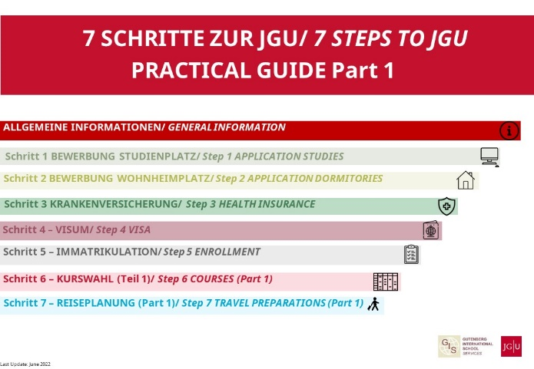

* 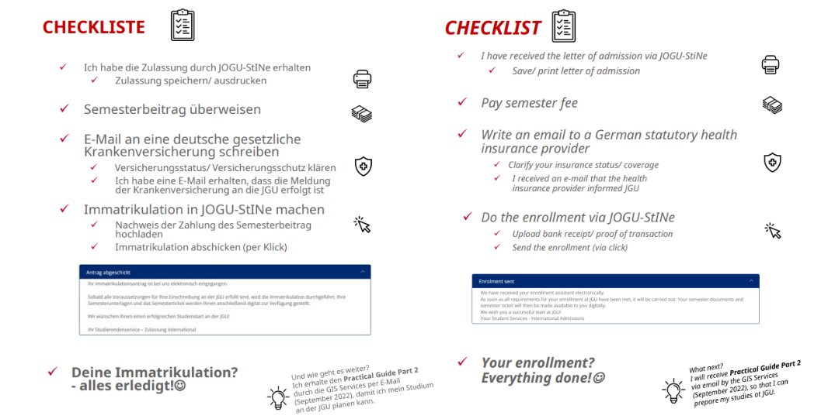It would be best if you have also already completed everything for   
  your **enrollment** (see the instructions in the email you received).

6



CHECKLIST

**All done**? Great! You have almost reached your goal:

JGU is on the horizon!

**You noticed something you haven’t done yet?**   
Then try to complete it as fast as possible or write us an email

so we can help you.

 **TO DO BEFORE YOU DEPART?**

* Carefully read through this **guide** 😊



**PLAN YOUR ARRIVAL**

* The first day you can officially **move in** to the

Studierendenwerk’s dormitories is October 4th, 2022

* The **InfoDays** take place from October 5th to October 12th, 2022.
* Order a **Basic-Pack** in case you need basic items for your   
  room in the Studierendenwerk’s dormitories (see page 12)

**PACKING YOUR SUITCASE – TAKE IMPORTANT DOCUMENTS**

Remember to bring all of your documents either as paper copy

or saved on your phone/computer:

* Passport/ID card
  + - EU citizens: passport or ID card   
      (at least 3 months to expiration date)
    - Non-EU citizens: passport   
      (at least 15 months to expiration date),   
      including residence permit or student visa.
* official letter of admission
* confirmation of semester fee payment
* certificate of health insurance coverage (home country)   
  (EU students: EHIC, for example)
* proof of corona vaccination
* Only scholarship recipients: certificate/confirmation of scholarship

7

IMPORTANT DATES - TIMELINE OF YOUR STAY

**Your journey starts here...**

|  |  |  |  |
| --- | --- | --- | --- |
| WELCOME WEEK | **ARRIVAL** | **From 04.10.2022** | Start of moving into the **dormitories** of the Studierendenwerk Mainz |
| **ENROLLMENT** | **Until 06.10.2022** | Enrollment via JOGU-StINe until 06.10.22 (see page 6)  Activate Account and install **JGU apps** to be able to use your semester ticket and your student ID (see page 39) |
|  | **05.10.2022/06.10.2022** | InfoDays: Day 1 & 2  Welcome to the campus (campus tours) |
| **07.10.2022/10.10.2022** | InfoDays: Day 3 & 4  Welcome to student life (info regarding course registration) |
| **11.10.2022/**  **12.10.2022** | InfoDays: Day 5 & 6  Welcome to the city (city tour) |
| [www.international-office.uni-mainz.de/infodays/](http://www.international-office.uni-mainz.de/infodays/) | |
| PREPARING STUDY START | **REGISTRATION FOR CLASSES** | **From 01.10.2022** | Use the **registration form** for courses and contact your academic advisors (see page 24). |
| **REGISTRATION FOR GERMAN COURSES** | **10.10. -**  **16.10.2022** | Register for the German courses of the ISSK via JOGU-StINe (see page 23) |
|  | **Further Tasks:**   * Get your **StudiCard** to be able to use printers on campus and cashless payment in cafeterias (see page 43) * Register at the city’s registration office **=Bürgerservice** Mainz   (see page 40-41)   * Register for **license fee** for public service media (see page 42) * Download your **certificate of enrollment** (see page 38) | |
| LECTURE PERIOD |  | **24.10.2022** | **Begin of lecture period** |
| **PUBLIC HOLIDAYS** | **01.11.2022**  **24.12.2022 -08.01.2023** | All Saints’ Day Christmas holidays |
|  |  | Time to study, live & explore   * Make use of your student ticket * Take part in social activities * Enjoy the #mainzgefühl * Study hard ☺ |

8



IMPORTANT DATES - TIMELINE OF YOUR STAY



|  |  |  |  |
| --- | --- | --- | --- |
| LECTURE PERIOD | **REGISTRA- TION**  **FOR EXAMS** | **~ first/second week of January** | This is the registration period for exams. If you haven’t discussed the exam procedure with your lecturer yet, now is the time!  (Note: Exchange students usually do NOT register via JOGU-StINe) |
| **DEADLINE REMATRI- CULATION SEMESTER FEE** | **15.01.2023** | You're staying longer than one semester? Remember to transfer the student semester fee by **January 15th, 2023**! You can find more information here:  [www.studying.uni-mainz.de/rematriculation/](https://www.studying.uni-mainz.de/rematriculation/) |
| **EXTENDING YOUR STAY?** | **before 31.03.2023** | **Tasks:**   * Apply for the extension in JOGU-StINe   (You will get more information about that from the GIS Services)   * Get the confirmation/approval from your home university and the confirmation from your department at JGU (both via email) and upload the confirmations in your application in JOGU-StINe. * Transfer the semester fee after receiving the notification from JOGU-StINe that your stay will be extended. * Extend your rental contract -and inform the Studierendenwerk- and all other contracts, Visa, health insurance... |
|  | **11.02.2022** | **End of lecture period** |
| DEPARTURE | **END OF STAY TASK LIST** | **Tasks:**   * You will receive the **Practical Guide Part 3 including all relevant information before the end of your stay** from GIS Services via email  at the end of the lecture period. * Download your **confirmation of exmatriculation** in JOGU-StINe (your account will remain active for another semester, see page 38) * Have your **Confirmation of Departure** signed by GIS Services * Contact your department for the **Transcript of Records**. * Deregister at the **Bürgerservice** Mainz * Deregister from the license fee for public media service | |
|  | | **31.03.2023** | **End of semester**  student ID/ticket expires |
| STAYING IN TOUCH | **ALUMNI NETWORK** | We hope you enjoyed your stay in Mainz and at JGU!  If you would like to stay connected and hear about  the events going on at JGU, then sign up for the alumni network!  [eng.alumni.uni-mainz.de](https://eng.alumni.uni-mainz.de/) | |

9



HOW TO GET TO MAINZ & CAMPUS

In the following, we will provide you with a quick overview on how to travel to Mainz and JGU. If you need further information, please check:

[www.uni-mainz.de/eng/118.php](http://www.uni-mainz.de/eng/118.php)



##### TRAVELING FROM THE AIRPORT TO MAINZ CENTRAL STATION

There are two airports close to Mainz:

1. **FRANKFURT INTERNATIONAL AIRPORT (30 MIN. AWAY)**

From there you can catch the train or S-Bahn to Mainz central station.

From Frankfurt/Flughafen Fern- bahnhof, trains: (EC), Intercity (IC), Intercity Express (ICE), tickets cost around EUR 13,60-. Travel time: about 20 minutes.

From Frankfurt / Flughafen Regio- nalbahnhof, trains: S-Bahn S8, Regi- onal Railway (RB), Regional Express (RE), tickets cost around EUR 5,60-. Travel time: around 30 minutes.

You can find the link to the train schedule here: [www.bahn.com/en/](http://www.bahn.com/en/)

10

**2. FRANKFURT HAHN AIRPORT (HUNSRÜCK REGION, 90 MIN. AWAY)**

From there you can travel by bus to Mainz central station. The “Flibco” bus leaves from Terminal 3 every three hours for Mainz central station. Tickets cost around EUR 14,50-. Travel time: around 90 minutes.

You can find the timetable here: [www.bohr.de/en/scheduled-services/busline-hahn-mainz](https://www.bohr.de/en/scheduled-services/busline-hahn-mainz)

You can book the tickets here: [www.flibco.com/en](http://www.flibco.com/en)

##### TRAVELING FROM MAINZ CENTRAL STATION TO THE CAMPUS

Plenty of buses and tram lines go from the central station to the campus. There are several diffe- rent stops due to the large sca- le of the university campus. We would recommend using tram lines 51, 53, 59 or the number 57 bus, because they stop directly at the main entrance of the campus.

All of the stations are marked with this image on the campus map:



**H**



HOW TO GET TO MAINZ & THE CAMPUS



RENTAL BIKES

Once you settle in, you can also explore the campus and the city by bike. You can

register online to use the Mainz city bikes.

You can find further informa- tion about registration and the bike stations here: [www.mainzer-mobilitaet.de/mehr-mobilitaet/meinrad](http://www.mainzer-mobilitaet.de/mehr-mobilitaet/meinrad)

You can find all of the rental bike stations on the campus by looking on the campus map (See Page 47).

For buses, tram and train schedules in and to Mainz you can check the app or homepage of the MVG – Mainzer Mobilität: [www.mainzer-mobilitaet.de/](http://www.mainzer-mobilitaet.de/)

RMV-Rhein-Main Verkehrsgesellschaft - which also covers the whole region: [www.rmv.de/c/en/homepage](https://www.rmv.de/c/en/homepage)

##### RIDE A BIKE IN MAINZ

You want to buy a bike? Have a look on portals like *ebay Kleinanzeigen*, postings on the

notice boards or in the Unibike shop.

„GREEN MOBILITY “

Sustainability and climate protection are two of our time’s central topics and everyone can contribute. JGU Mainz is glad about every exchange student who (if possible) chooses to travel to the university using **climate friendly modes of transport** (train or bus instead of airplane or car).

Mainz is easily reached with a train from most European cities via Frankfurt am Main.

**Information for Erasmus+ students**: The Erasmus+ program is also pursuing the goal of becoming more sustainable – ask your home university if you can receive the special “green mobility” grant for your trip. For more information about this topic please also go to the website “Green Erasmus”: [www.greenerasmus.org](http://www.greenerasmus.org)

11



ACCOMMODATION

STUDIERENDENWERK MAINZ DORMITORIES

If you applied for a room in the dormitories within the application deadline, you should already have had contact with the Studierendenwerk Mainz by now ([wohnen@studierendenwerk-mainz.de](mailto:wohnen@studierendenwerk-mainz.de)) or you may have already received a confirmation for a room.

Here you will find an overview of all the dormitories of the Studierendenwerk Mainz (Stw Mainz). To find out how to get there, simply click on your dormitory and you will be provided with directions.   
[www.studierendenwerk-mainz.de/en/wohnen/dormitories](https://www.studierendenwerk-mainz.de/en/wohnen/dormitories)

ROOM EQUIPMENT: BASIC PACK

Every room is equipped with furniture (wardrobe, bed, chair, table and desk chair). Please keep in mind that the follo- wing is NOT provided:

Bedding (blanket, pillow, bedcovers) & towels

Dishes, cooking pots & cutlery

If you can’t or don’t want to transport these items, you can order a basic package that includes the listed items for 75 euros. More information: [www.studierendenwerk-mainz.de/en/internationales/housing-international/basic-room-equipment](http://www.studierendenwerk-mainz.de/en/internationales/housing-international/basic-room-equipment)

RENT

Transfer the rent and the deposit to the Studierendenwerk Mainz **before** **the contract period** begins. Information on payment and the account information is in the email “Mietvertrag angekommen” from the Studierendenwerk.

12

Once you have returned the contract digitally to [wohnen@studierendenwerk-mainz.de](mailto:wohnen@studierendenwerk-mainz.de), send the original contract with your original signature (pen on paper😊) to the following address within the next 10 days:

Studierendenwerk Mainz

Abteilung Studentisches Wohnen

Staudingerweg 21

55128 Mainz

If you do **not** live in Europe, take the original contract with you and either drop it in the letterbox at the Info point (Studierendenwerk Mainz, Abteilung Studentisches Wohnen, Staudingerweg 21, 55128 Mainz), hand it in there, or send it via regular mail once you arrive at JGU.

DEPOSIT

When moving in, you are required to pay a one-time deposit ("Kaution"= the sum of two month's rent), which will be returned to you when you move out, providing that you have left your room in good condition. Report any damages present when you move in to your dormitory’s facility manager office and have them entered in the log.



ACCOMMODATION

MOVING-IN

Head directly to your dormitory on moving-in day. The **facility manager** will give you the keys to your room.

**The earliest day** for moving in during the winter semester 2022/23 is **October 4th**, as October 1st and 2nd fall on a weekend and October 3rd is a public holiday. It is not possible to move in on these days.

If you arrive on October 4th, you can comfortably participate in the InfoDays starting on October 5th.

The Studierendenwerk will send you further information on the moving-in process via email shortly before you move in.

You can only move in during the opening hours of the respective caretaker (“**Hausmeister**”) of the dormitory. You can find the office hours here: [www.studierendenwerk-mainz.de/en/wohnen/moving-in/office-hours-of-the-caretaker](https://www.studierendenwerk-mainz.de/en/wohnen/moving-in/office-hours-of-the-caretaker)

Please note this when you book your train/flight and inform the caretaker of your dormitory in advance when exactly you will be arriving (email/phone), so that you are not faced with closed doors.

Here you can download the Studierendenwerk's dormitory brochure again :

[www.studierendenwerk-mainz.de/fileadmin/user_upload/Wohnen/Wohnheimbroschuere/Wohnheimbroschuere_web.pdf](https://www.studierendenwerk-mainz.de/fileadmin/user_upload/Wohnen/Wohnheimbroschuere/Wohnheimbroschuere_web.pdf)

For all general information about housing/dormitories (prices, important links, application, rental period, sublease, private accommodation…), please check again Practical Guide 1, chapter "Application Dormitories"

CONTACT

Studierendenwerk Team Housing:

[wohnen@studierendenwerk-mainz.de](mailto:wohnen@studierendenwerk-mainz.de)

Info-Point

Studierendenwerk Mainz

Staudingerweg 21 (Studihaus see campus map 17)

55128 Mainz

Looking for private accommodation?!

[www.studierendenwerk-mainz.de/en/wohnen/private-living/page](http://www.studierendenwerk-mainz.de/en/wohnen/private-living/page)

13

## GIS GIS SERVICES - THE FIRST ADDRESS FOR YOUR STAY



GUTENBERG INTERNATIONAL SCHOOL SERVICES

The Gutenberg International School Services (GIS Services) are your main contact for your time abroad at JGU Mainz.

We are here for you in order to make your time in Mainz as pleasant and successful as possible. We will accompany you through all the phases of your study abroad at JGU – from preparation at home to advice and support here on the spot, to your departure at the end of your stay.

If you have any questions concerning your stay – administrative matters, accommodation, health insurance, on–campus orientation or study organization – don’t hesitate to contact us!

Either we will be able to answer your question right away or we will know whom to ask. ☺

You can reach us via email and telephone or during our office hours.

We are looking forward to welcoming you in Mainz soon!

**During the InfoDays from Ocotber 5th to October 10th we will be available daily to answer your questions (Details will follow via email).**

Your GIS Services Team

14

OUR SERVICES AT A GLANCE

you can contact/visit us for...

...Advice on

* Administrative matters
* Health care
* Visa matters
* Financial matters
* Accommodation
* Study organization

...Help and support for any other problem and question

...Or just to chat with us ☺



|  |
| --- |
| GIS SERVICES  Building: Forum universitatis 2  Room: 00-241  Phone: +49 6131 39-20695  Email: [gis@international.uni-mainz.de](mailto:gis@international.uni-mainz.de)  Please check our website for more information:  [www.international-office.uni-mainz.de/exchange/](http://www.international-office.uni-mainz.de/exchange/) |



15

HOW TO GET TO THE InfoDays

ALTE MENSA

The Welcome Week/ InfoDays events take place in the building "Alte Mensa" near the main entrance of the JGU campus. You can find the building by following the description at the bottom of this page and our signs.

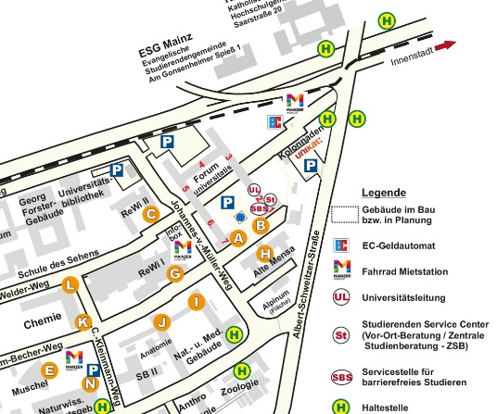

Tram stop of 51/53/59

Bus stop 57

**Please follow the signs "InfoDays"**

1. Take the trams 51/53/59 from the central station
2. Go straight through the main entrance
3. Turn left after you passed the first
4. archway and go across the square with the fountain
5. The big building in front of you is the „Alte Mensa“

WELCOME WEEK

OFFICE GIS SERVICES

You will find the GIS Services office close to the "Alte Mensa" in the "FORUM UNIVERSITATIS" building, entrance 2 (the only one with a balcony above). You will find us on the ground floor in the hallway to the left, at the very end of the hallway in ROOM 00-241.

WELCOME WEEK



INFODAYS

During the InfoDays, JGU welcomes all of the newly arrived international exchange students on the Mainz campus.

Over the course of the InfoDays, you will get to know the campus together with us and find out all the necessary information for a good start into your exchange semester at JGU.

 You are unable to attend the InfoDays?

First of all, don’t panic – you can still study at JGU!

But please do inform us of your absence in advance via email: [gis@international.uni-mainz.de](mailto:gis@international.uni-mainz.de). We will send you further information regarding your next steps and when you can meet us.

The Confirmation of Arrival for Erasmus+

students will be signed by the GIS Services during the InfoDays.

16

### 

### INFODAYS PROGRAM

We will send you a detailed

program via email.

###### **DAY 1 & 2 – October 5th and 6th, 2022** WELCOME TO JGU ☐ Welcoming address ☐ Campus tour in groups

**DAY 3 & 4 –   
October 7th and 10th, 2022**WELCOME TO YOUR STUDIES AND STUDENT LIFE  
  
☐ Online presentation on how to sign up for courses

☐ Information on offers on campus and in the subjects

**DAY 5 & 6 –   
October 11th and 12th, 2022**WELCOME TO THE CITY

###### ☐ Guided city tour through Mainz

###### ☐ More events 😊 Party, Brunch, Pub crawl, Beerpong (details will follow)

WELCOME WEEK



IMPORTANT THINGS TO DO AFTER YOU ARRIVE IN MAINZ



STARTING INTO   
YOUR STUDIES

activate your student account (page 37)

download and install both JGU apps (page 39)

upload your picture in the app (page 38)

activate your student ID card and semester ticket in the app “JGU Ausweise”(page 36)

apply for your library account through the app (page 45)

update your address (page 38)

get a StudiCard (page 43)

get your Confirmation of Arrival (page 16)

take part in the InfoDays and get to know the campus (page 16)

[www.international-office.uni-mainz.de/infodays/](https://www.international-office.uni-mainz.de/infodays/)

sign up for the German language course (Page 23)

sign up for courses (page 24)

MOVING IN

move into your dormitory room:   
Basic- Pack, taking possession of your room, keys (page 12)

hand in your original rental contract (page 12)

activate WiFi



LIVING IN MAINZ

register at the city’s registration office (Bürgerservice)  
(page 40/ 41)

appointment for your visa

(page 41)

license fee (page 42)

open an account (optional/

page 41)

take part in a city tour (page 16)



Special Office Hours

during the InfoDays  
**from October 5th to October 10th, 2022**, GIS Services will be available to answer your questions the whole day. (Further details will be sent via email).

17



WELCOME WEEK

STUDYING IN MAINZ IS MUCH MORE THAN “JUST” STUDYING

VIRTUAL INFOCAFÉ

**Always well advised!**

Find out more about the services and advising offers for every stage of your life!

**Broaden your academic horizon!**Take a look at the academic options JGU has to offer!

**Lonely? Not with us!**Get to know students and citizens of Mainz!

**Boredom? What’s that?**

Sports, music, art, theatre, excursions everywhere you look!

Did we spark your interest in the different offers?  
Then be curious - you will find the current presentation here soon [www.international-office.uni-mainz.de/infodays](http://www.international-office.uni-mainz.de/infodays)

UNIVERSITY GROUPS (“Hochschulgruppen”)

Get to know the different student groups at our university through the virtual university group fair (link in German):   
[asta.uni-mainz.de/service/hochschulgruppen/hsg-vorstellung](http://asta.uni-mainz.de/service/hochschulgruppen/hsg-vorstellung)

STUDENT COUNCILS (“Fachschaften”)

The student councils are elected representatives for all students within a specific faculty. You can find out more about upcoming events for the beginning of the semester on your faculty’s student council page. Here is a list of all the student councils (link in German):  
[www.studium.uni-mainz.de/fachschaften/](https://www.studium.uni-mainz.de/fachschaften/)

Do you want to be part of ICON?

ICON is a conference organized by students for students. Would you like to join the organization team or participate in the conference? You can find more information under this link:

[icon.uni-mainz.de/](https://icon.uni-mainz.de/)

18



WELCOME WEEK

# GET READY FOR YOUR STUDIES

In this chapter, we will provide you with all the necessary information on how to organize and succeed in your studies!



Watch our online presentation on October 7th **or** 10th during the InfoDays (the program will follow via email) and take a look at the additional information and offers of the subjects at:

www.international-office.uni-mainz.de/infodays/

##### WELCOME TO YOUR STUDIES

You are already enrolled at JGU – now your studies can finally begin!

In cooperation with the departments at JGU, we will try to answer all of your questions!

WHO CAN ANSWER MY QUESTIONS?

THE GIS SERVICES

…provide an **overview** over your exchange semester at JGU

…can answer **general** questions about the course registration procedure

Which deadlines do I need to be aware of?

Who are my academic advisors?

Where do I find the course catalogue?

THE DEPARTMENTAL ACADEMIC ADVISORS AND   
THE ERASMUS+ DEPARTMENTAL COORDINATORS

…can answer all of your **academic**  questions

…give advice about your course selection and confirm

your choice of courses

Is it possible to attend courses from different departments?

Which courses are taught in English or in another foreign language?

19



# WHAT JGU HAS IN STORE FOR YOU

As an exchange student, you have many options to fill your timetable. In the following, we will inform you of JGU's various offers and tell you where you can find the right courses for you.

##### GUTENBERG INTERNATIONAL SCHOOL

The Gutenberg International School (GIS) offers courses for students with no knowledge of the German language or students who have German language skills on an intermediate level.

Our interdisciplinary GIS courses mainly deal with the topics (Ger- man) history and culture, as well as social sciences and society.

Additionally, you can improve your German language skills with our special offers for exchange students.

You can either earn all your credits with GIS courses or complement the courses from your subject in case you want to gain insight into other fields. Please note: the registration for the courses must be done in the subjects in which these courses are offered and **not** through the Gutenberg International School!

As a special service, we will also provide you with a list of all the courses taught in languages other than German at JGU which are open for exchange students.

So, just have a look what JGU has in store for you!

You want to...

... improve your German Skills?

... earn credits?

... broaden your horizon?

Contact: Dr. Thomas Weik (GIS) [gis@international.uni-mainz.de](mailto:gis@international.uni-mainz.de)



20



WELCOME WEEK

COURSE OFFER

GIS- SPECIAL COURSES FOR EXCHANGE STUDENTS

Are you interested in German history & culture and/ or History & Culture in general? Do you want to learn about the influence of the past and its effect on today's culture? Just take a look at the



HISTORY

& CULTURE

interdisciplinary offers in English in these areas.

Do you study social sciences or just want to see what kind of research is done here in Germany in this field (from international relations or innovation and technology sociology to media and globalizati- on)? Then these English-language offers may be the right fit for you.

SOCIAL SCIENCE & SOCIETY

GERMAN LANGUAGE

Would you like to study at JGU primarily to improve your German language skills and learn more about German literature and culture at the same time?



We may have just what you need.

LIST OF NON-GERMAN-LANGUAGE COURSES OPEN FOR EXCHANGE STUDENTS

Studying at JGU without sufficient German language skills is not possible? Wrong! Check out the JGU courses offered in languages other than German (which also includes

the GIS courses in languages other than German). As an

exchange student, you are very flexible in taking courses from various departments, so you can construct your class schedule according to your wishes.

NON-GERMAN COURSES

21

Check out the course offer on:

[www.international-office.uni-mainz.de/exchange/gis/](http://www.international-office.uni-mainz.de/exchange/gis/)

JGU GENERAL OFFER

You already know our main study-platform JOGU-StINe from your application and enrollment. You can also find the general course catalogue there, which lists (nearly) all of the courses offered by the various subjects, departments and other institutions.

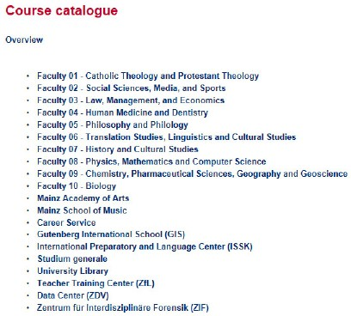

You don't need a login for the course catalogue! jogustine.uni-mainz.de

GENERAL COURSE OFFER

GIS COURSES FOR   
EXCHANGE STUDENTS

You can find all offers on the website: [www.international.uni-mainz.de/exchange/gis/](http://www.international.uni-mainz.de/exchange/gis/)

(See pages 20 and 21)

STUDIUM GENERALE

Interdisciplinary

lecture series that deals with contemporary issues in the fields of philoso- phy, cultural studies and interculturalism.

ZDV COURSES –

COMPUTER SKILLS

Courses offered by the ZDV (Data Center) for all students (e.g. PowerPoint, Photoshop etc.)

ACADEMIC WRITING SKILLS

Tutorials for academic writing open for students from all subjects. [www.writingcenter.uni-mainz.de/](http://www.writingcenter.uni-mainz.de/)

22

THERE ARE MANY OPTIONS WAITING FOR YOU!

So don't hesitate to ask the academic advisors to organize your timetable and find out the courses that fit best for YOU.

## WELCOME WEEK



LEARNING GERMAN

ISSK – INTERNATIONALES STUDIEN- UND SPRACHENKOLLEG

REGISTERATION

**Registration phase**

**10.10.2022, 08:00 a.m. - 16.10.2022, 23:59 p.m.**

Please register for the German courses during this period. You can register for the German courses of the ISSK via JOGU-StINe. In addition, you have to upload a language certificate after registration.

Detailed information about the registration and the placement (placement test; approved/required language certificates) can be found on the ISSK website:

[issk-en.uni-mainz.de/registration-for-the-german-courses/](https://issk-en.uni-mainz.de/registration-for-the-german-courses/)

(= International Preparatory and Language Center)

 BINGER STR. 14-16

21

COURSES OFFERED

Classes at levels A1- C1 meet twice or three times a week for a total of 4 to 6 academic units per week.

For every course you successfully complete, you can obtain ECTS (after passing the exam).

You find the course overview in [JOGU-StINe](https://jogustine.uni-mainz.de/scripts/mgrqispi.dll?APPNAME=CampusNet&PRGNAME=ACTION&ARGUMENTS=-AE1KQHM0~g2kwzUsgFcyrhn8ermEHbEuo8QXjJQFGVT1mQTK7vSUGBHO~4ufYC2j7ewpaRQ4BlFtlbDdtCEh2EA7qc92dr619Fdh6dS0VLzphQGZq7FK38ozoVONUwF326VsCo5G2J0YUz1mq1BlivvOuuhf8V21265aJh9NZnJzGB5RKuJGIfVabpHDr0-gxuyo9Z2ynlrfKPs0_) (course catalogue> winter semester 2022/23> ISSK> German as a foreign language)

CONTACT GERMAN COURSES



Ms. Dr. Dorota Piestrak-Demirezen [piestrad@uni-mainz.de](mailto:piestrad@uni-mainz.de)

23

WELCOME WEEK



1

HOW TO REGISTER

FOR CLASSES

 

STEP 1: DOWNLOAD AND FILL IN THE REGISTRATION FORM

1. Download the registration form. You can fill it out on your computer and save it or print it out.
2. Write down all courses you would like to attend.

Please note:

* The total number of courses should not exceed **30 ECTS** each semester.
* Your **major** (the subject in which you are enrolled at JGU, compare to your letter of admission) should account for 15 ECTS minimum. If you have to achieve more than 15 ECTS, the remaining credits can also be chosen from different subjects.
* **Erasmus+ students:** Please try to stick to your **Learning Agreement** as much as possible. Please make sure that you enter the correct Erasmus+ departmental coordinator. **Please note the information in the Practical Guide Part 1 (“7 steps to JGU”).**

|  |
| --- |
| PLEASE NOTE  Special conditions apply to LAW and BUSINESS & ECONOMICS  students.  Please visit the links below:  BUSINESS & ECONOMICS:  [erasmus.wiwi.uni-mainz.de](https://erasmus.wiwi.uni-mainz.de/)  LAW:  [auslandsbuero.jura.uni-mainz.de](https://auslandsbuero.jura.uni-mainz.de/) |

In order to register, you will need to select all the courses you would like to attend on a registration form and have it confirmed by the academic advisor of the subject you would like to take classes in.



You can download the registration form, the list of academic advisors and further explanations about the registration process here: [www.international.uni-mainz.de/exchange/gis/](http://www.international.uni-mainz.de/exchange/gis/)

(in the download menu)

24

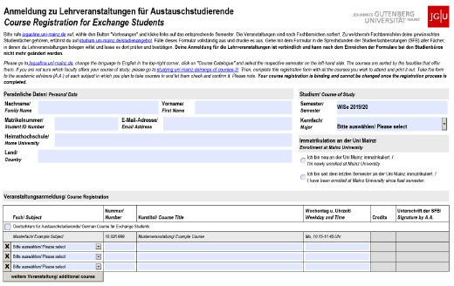

1 Enter your personal data

2 Choose “I'm newly enrolled in Mainz"

3 Enter your choice of courses

This part will be filled in

by the academic advisors

There is no general deadline for the registration. Please check with your department!

STEP 2: PERSONAL CONSULTATION WITH YOUR ACADEMIC ADVISOR

1. Check the list of academic advisors (see links on previous page). Choose the relevant person(s) and contact them by email or during their office hours.
2. They will advise you and officially confirm your choice. Afterwards, they will forward the form to the Studienbüro (office for the registration of courses).
3. Repeat the process once for every subject in which you would like to attend classes.

2

**Please note: Your registration is binding and cannot be changed once you have submitted the form!**

25

## WELCOME WEEK



REGISTRATION FOR EXAMINATION

There is no general deadline for the exam registration. Please check with your department

There is **no general rule for exam registrations** (except for students of Law & Economics - see page 24).

**Grade distribution:**

You will receive grades between 1.0 and 5.0. You will pass the examination if your grade is between 1.0 (very good) and 4.0 (sufficient). You fail if you get a 5.0 (not sufficient).

**Exeption Law:** Points between 0 and 18 (You pass with 4 points)

**Credit Points (CP)/ ECTS:**

The workload of 1 CP is up to 30 hours. They are based on the ECTS (European Credit Transfer System).

In each course, you have to ask your teacher which regulations apply to you. Usually, exams are taken at the end of the lecture period or shortly after.

**Please consider this when planning your departure!**

|  |  |
| --- | --- |
| TYPES OF EXAMS  There are usually four different types of  WRITTEN EXAM (“KLAUSUR”) | exams depending on the classes you take: WRITTEN TERM PAPER  (“SCHRIFTLICHE HAUSARBEIT”) |
| Usually written at the end of the semester in one of the last sessions or shortly after the end of the lecture period. | After consulting with your teacher, you choose a topic connected to your class to write a term paper on. |
| ORAL EXAM (“MÜNDLICHE PRÜFUNG”) | PRESENTATION (“REFERAT”) |
| An examination in the form of a discussi- on between you and your examiner, on a certain academic subject. | The teacher assigns a topic that is relevant to the course. You have to prepare an oral report, either alone or in a group. Presentations are usually held during the semester in one of the class sessions. |

26

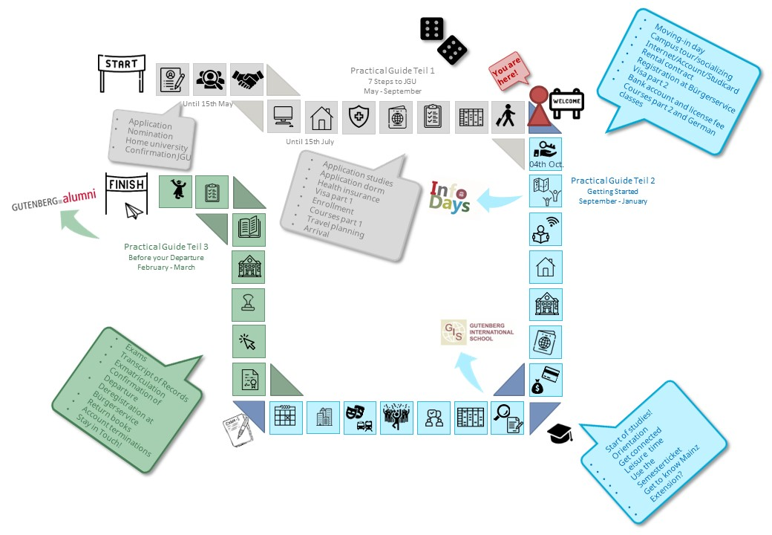

27



LIFE ON CAMPUS

# WHERE TO EAT?

There are plenty of possibilities to refill your energy supply before the next course – here's a culinary overview of the campus. You can check the daily offer and the current opening hours here: [www.studying.uni-mainz.de/refreshment-facilities-on-campus/](https://www.studying.uni-mainz.de/refreshment-facilities-on-campus/) or in the JGU app. Please note   
that there may be closures or special access rules due to the Corona pandemic.



|  |  |
| --- | --- |
| 1 | ZENTRALMENSA 13  Staudingerweg 15  Offers hot meals at 4 different counters (Theken) including vegetarian or vegan options  *you can only pay with the StudiCard!* |
| 2 | MENS@RIA  Staudingerweg 15  Offers snacks as well as hot meals and coffee |
| 3 | BALI BISTRO  Staudingerweg 21  Offers burgers, pokebowls &more |
| 4 | INSGRÜNE – KAFFEEBAR IM PHILO  Jakob-Welder-Weg 18, Philosophicum  Offers snacks like bagels, pastries, smoothies and fresh coffee |
| 5 | DIWAN  Johann-Joachim-Becher-Weg 23a  Middle Eastern cuisine, offers kebap, fala- fel, pizza and pasta & rice dishes  [www.diwan-mainz.de](http://www.diwan-mainz.de/) |
|  |  |



3BALI BISTRO



1/2 ZENTRAL- MENSA/ MENS@RIA

4 I**NSGRÜNE** – KAFFEEBAR IM PHILO



5 DIWAN

28





MAIN ENTRANCE C

7 MENSA GEORG FORSTER



8 CAFÉ REWI

12 KHG MENSA







11 WERNER´S BACKSTUBE/ UNIKAT



10 BARON

29

9 KULTURCAFÉ

|  |  |
| --- | --- |
| MENSA GEORG FORSTER  Jakob-Welder-Weg 12, Georg-Forster Gebäude  Offers warm meals - including vegetari- an options as well as sandwiches, pastry, salads, sweets and coffee | 7 |
| CAFÉ REWI  Jakob-Welder-Weg 9, ReWi Gebäude Two different meal options – including a vegetarian option, stews, as well as sandwiches, salads, sweets and coffee. Highlight: the MüsliBar (cereals) for an energized start to your morning! | 8 |
| KULTURCAFÉ/Q-KAFF  Johann-Joachim-Becher-Weg 5  Offers warm meals, sandwiches, snacks, pastries & coffee  But that’s not all! In the evening, it transforms into an event location! [www.kulturcafe-mainz.de/veranstaltun](http://www.kulturcafe-mainz.de/veranstaltungen/)gen | 9 |
| BARON  Johann-Joachim-Becher-Weg 3 Offers warm meals, a bit more pricey  But that's not all! In the evening, it transforms into an event location! [www.baron-mainz.de/veranstaltungen](http://www.baron-mainz.de/veranstaltungen/) | 10 |
| WERNER'S BACKSTUBE/UNIKAT  Jakob-Welder-Weg 1  Bakery, offers sandwiches, pastries, and coffee | 11 |
| KHG MENSA  Saarstraße 20  Offers two meals – meat and vegetarian options | 12 |

LIFE ON CAMPUS



# LEISURE TIME - SOCIAL AND CULTURAL ACTIVITIES

It’s not all about studying… We have some ideas for you!

How about...

SINGING?

The UniChor of the **Collegium**

**Musicum** is open for all JGU students and staff.

[www.unichor-mainz.de/home.html](http://www.unichor-mainz.de/home.html)

**The Authentic Voices** are the choir of the English Department of JGU. They meet every Thursday (open to all students). [www.authentic-voices.de](http://www.authentic-voices.de/)

SPORTS?

11

The “**Allgemeiner Hochschulsport (AHS)**” of JGU offers a broad range of sports. You will find everything from Aerobics to Yoga.

The best thing: it’s for free!

(Apart from certain special courses.) You can check out and download the program on the website (German Link). [www.ahs.uni-mainz.de/](http://www.ahs.uni-mainz.de/)

30

A TASTE OF THE WINE REGION?

Part of your program to explore Mainz should definitely be a trip through the vineyards. "**Campus Mainz**" organizes monthly trips to the vineyards or wine markets in the region. Costs are around EUR 15 per person.

You can check out their program on their website or get inspired for your own trips. [www.campus-mainz.net/weinexpress/](http://www.campus-mainz.net/weinexpress/)

GOING TO THE CAMPUS CINEMA?

Every Monday and Wednesday, the lecture hall N2 in the “Muschel” (see campus map no. 8 ) turns into a **cinema**. You can purchase drinks at the entrance. You can find the program here: [www.unifilm.de/studentenkinos/Mainz](http://www.unifilm.de/studentenkinos/Mainz)

LEARNING A NEW SKILL?

The “**Kulturkurse**” are a great opportunity to learn a skill you always wanted to learn, like dance, survival in the woods, calligraphy or a software program – to name just a few examples of the varied program.

[www.campus-mainz.net/kulturkurse/](http://www.campus-mainz.net/kulturkurse/)

BEING A JOURNALIST?

Students who want to gain experience working in the media (TV, radio, online) have several opportunities at JGU.

TV made by students for students. The team of **CampusTV Mainz** produces broadcasts and videos about all kinds of topics connected with studies, research and life on the JGU campus.

Open to all students.

[www.campus-tv.uni-mainz.de/wp2/](http://www.campus-tv.uni-mainz.de/wp2/)

**Campusradio** is a JGU project to give students insight into the work of a radio station. Students learn how to produce their own radio broadcast. [www.campusradio.uni-mainz.de/tag/campusradio-mainz/](http://www.campusradio.uni-mainz.de/tag/campusradio-mainz/)

**CAMPUS Mainz** is a non-profit organization that offers campus news, food, events, studies and more on their website. If you would like to support the editors and write articles, you can contact them via email.

[mail@campus-mainz.net](mailto:mail@campus-mainz.net)

[www.campus-mainz.net](http://www.campus-mainz.net)

MEETING NEW PEOPLE?

There are several university groups at JGU that organize events and activities with an international focus. These include the LEI Erasmusteam and the AStA International team.

We as **LEI Erasmusteam** love to bring people together.

We organize socials, have fun together or show you around Mainz and organize day trips.

We want to meet you follow us on Instagram [@erasmusteam_mainz](https://www.instagram.com/erasmusteam_mainz/) ([www.instagram.com/erasmusteam_mainz/](https://www.instagram.com/erasmusteam_mainz/))

Our first events in winter semester 2022-23 will take place on October 9th (Hangover Brunch), October 12th (Pub Crawl), and October 14th (BeerPong). We look forward to seeing you there!

We from **ASTA INTERNATIONAL** look forward to welcoming you to the first party of the winter semester on October 8th and celebrating together with you.

[@asta.international.unimainz](https://www.instagram.com/asta.international.unimainz/) ([www.instagram.com/asta.international.unimainz/](https://www.instagram.com/asta.international.unimainz/))

GOING TO THE THEATRE?

You can visit the **State Theatre Mainz** for free!

You can go to the box office and get a ticket for free 3 days before the perfor- mance you want to see. There, you will need to show your student ID and a picture ID in order to get the ticket. [www.staatstheater-mainz.com/web](http://www.staatstheater-mainz.com/web/)

Gutenbergplatz 7, city center

31

Check out the map in the end of the guide!

LIFE ON CAMPUS

# ON-CAMPUS ORIENTATION AND USEFUL ADDRESSES

|  |
| --- |
| ALLGEMEINER STUDIERENDEN- AUSSCHUSS (ASTA) – 15  TEXT CAFÉ & LEGAL ADVICE |
| The AStA (General Student Committee) has various sections. This includes the section for international students, which offers support in the process of integration on campus and in Mainz through cultural events, workshops, seminars. Offers are e.g. the **Textcafé** (support with writing academic texts in German)  [www.writingcenter.uni-mainz.de/](http://www.writingcenter.uni-mainz.de/), support for socially disadvantaged students or the **legal advice** for international students  [en.asta.uni-mainz.de/sb/asta/international/](https://en.asta.uni-mainz.de/sb/asta/international/)  Studierendenhaus, Staudingerweg 21 |
| HEALTH INSURANCE 14 |
| Staudingerweg 21  Techniker Krankenkasse (TK) is a German public health insurance provider and has an office on our campus.  Studierendenhaus, Staudingerweg 21  [students.jgu@tk.de](mailto:students.jgu@tk.de) |
| CAREER SERVICE 25 |
| If you are thinking about staying and working in Germany, the Career Services’ offers may be of interest to you.  [career@uni-mainz.de](mailto:career@uni-mainz.de)  www.uni-mainz.jobteaser.com |

SERVICES

|  |
| --- |
| GUTENBERG INTERNATIONAL SCHOOL SERVICES/ 1  INTERNATIONAL OFFICE |
| Here you can get help with any  questi on concerning your stay.  Forum universitatis, entrance 2, Ground floor, room 00-241  *Office hours:* please check the website [www.international-office.uni-mainz.de/exchange/](http://www.international-office.uni-mainz.de/exchange/)  [gis@international.uni-mainz.de](mailto:gis@international.uni-mainz.de) |
| STUDENT SERVICES/ INFO DESK 2 |
| The Student Service Center (Infodesk) is responsible for the general student administration.  Forum universitatis, Entrance 1, 1st floor  [www.studying.uni-mainz.de/service](http://www.studying.uni-mainz.de/service/) |
| STUDIERENDENWERK MAINZ (Stw Mainz) 17 |

The Studierendenwerk Mainz supports students in social, economic and cultural aspects and allocates the dormitories. They are the right contact for all questions about housing.  
  
Info-Point

Studierendenhaus/Studi-Haus

Staudingerweg 21 , 55128 Mainz

[www.studierendenwerk-mainz.de/en/internationales](http://www.studierendenwerk-mainz.de/en/internationales)

[wohnen@studierendenwerk-mainz.de](mailto:wohnen@studierendenwerk-mainz.de)

32

|  |
| --- |
| AGENTUR FÜR ARBEIT MAINZ –  BLEIB! 16 |
| Are you thinking of staying and working in Germany? The Agentur für Arbeit Mainz can help you with applications for internships and jobs in Germany. Advice is offered in German and English, as is the preparation and correction of application documents, workshops and trainings for international students and graduates. All of these services are free.  Staudingerweg 21, entrance F [www.arbeitsagentur.de/vor-ort/mainz/bleib](https://www.arbeitsagentur.de/vor-ort/mainz/bleib) [mainz.152-berufsberatung@arbeitsagentur.de](mailto:mainz.152-berufsberatung@arbeitsagentur.de) |
| MENTAL HEALTH SERVICES FOR STUDENTS (PBS) - me@JGU 19  me@JGU |
| The Mental Health Services (PBS) are open to all JGU students. They provide professional help (counseling, seminars, courses) in coping with psychological problems of any kind that may arise during studies and everyday life.  Additionally, the JGU Health Services offer courses like “Test Anxiety”,“Writers Block”, “Stress Management”.  If you need tips or information, you can have a look at **me@JGU**, an online portal for JGU students. The website contains exercises on various topics in form of texts, audios, videos and podcasts.  [www.me-at-jgu.de](http://www.me-at-jgu.de/) [www.pbs.uni-mainz.de/](http://www.pbs.uni-mainz.de/)  [pbs@uni-mainz.de](mailto:pbs@uni-mainz.de) Hegelstraße 61, 5th floor  To make an appointment, you can write an email or call during office hours: Mo - Fri 9 a.m. - 12 p.m |

OFFICE OF ACCESSIBILITY (SBS) 18

If you are handicapped, chronically ill or have mental health issues, the Office of Accessibility can provide support and advice on personal problems, problems with studies, legal questions, organisation and financing.

Forum Universitatis1, room 02-101   
[accessible.uni-mainz.de/](https://accessible.uni-mainz.de/)  
[barrierefrei@uni-mainz.de](mailto:barrierefrei@uni-mainz.de)



INTERNATIONAL PREPARATORY AND LANGUAGE CENTER (ISSK) 21

You want to learn German or another foreign language?

[issk-en.uni-mainz.de/registration-for-the-german-courses/](https://issk-en.uni-mainz.de/registration-for-the-german-courses/) also see page 23

Binger Straße 14-16

EQUALITY AND DIVERSITY OFFICE 26

33

Offers to promote equal opportunities, diversity and realize a discrimination-free, diversity-sensitive culture (advice, coaching for career planning, conflict resolution, diversity trainings, gender consulting)

[gleichstellungsbuero@uni-mainz.de](mailto:gleichstellungsbuero@uni-mainz.de)

If you have questions about studying as a parent, this is the right office for you.

Forum universitatis, entrance 3

[www.family-services-center.uni-mainz.de/](https://www.family-services-center.uni-mainz.de/)

[familien-servicebuero@uni-mainz.de](mailto:familien-servicebuero@uni-mainz.de)



FAMILY SERVICE CENTER 24



LIFE ON CAMPUS

BUILDINGS & LIBRARIES

|  |
| --- |
| UB - UNIVERSITY LIBRARY 4 |
| The University Library consists of the Central Library, eight branch libraries and the central archive.  Jakob-Welder-Weg 6  Overview of locations and opening hours for all UB locations (link in German):  [www.ub.uni-mainz.de/de/standorte](http://www.ub.uni-mainz.de/de/standorte) |
| REWI GEBÄUDE 3  (LAW & ECONOMICS BUILDING) |
| The Faculty of Law, Management, and Economics.  In the so-called ReWi (Recht und Wirtschaft) building, you can find the departments of law, economics, and business education. Lecture hall RW1 is the biggest on campus, with almost 1000 seats. The departmental library is also located here.  Jakob-Welder-Weg 9 |
| GEORG FORSTER GEBÄUDE (GFG) 5 |
| The Institute of Education, the Depart- ment of Political Science, the Depart- ment of Communication, and the Institute of Sociology are all located in the GFG. Various departmental libraries as well as the USA library are located here. The library is closed on public holidays.  Jakob-Welder-Weg 16  PHILOSOPHICUM  6  The Humanities library (Bereichsbibliothek Philosophicum) is a combination of 20 former |

departmental libraries of Faculty 05 (Philosophy and Philologies) and Faculty 07 (History and Cultural Studies) as well as the School of Music.

The names of the lecture halls and rooms in the Philosophicum start with a “P”. Lecture Hall P1 is the biggest in the Philosophicum, and it is located outside the main entrance of the building. Films and student plays are occasionally shown here during the semester.

Jakob-Welder-Weg 18

HOCHSCHULE FÜR MUSIK (HfM)

7

(SCHOOL OF MUSIC)

The Mainz School of Music is the only college of music in Rhineland-Palatinate! You can go to concerts here and join the choir or the orchestra (page 30).

Jakob-Welder-Weg 28

[www.musik.uni-mainz.de/veranstaltun-gen/veranstaltungskalender](http://www.musik.uni-mainz.de/veranstaltungen/veranstaltungskalender)

UNIVERSITY MEDICAL CENTER 23

The map of the campus of the University Medical Center can be found here [www.unimedizin-mainz.de/header/anfahrt.html](https://www.unimedizin-mainz.de/header/anfahrt.html) (link in German)

34

KUNSTHOCHSCHULE

At the Kunsthochschule you can go to

exhibitions or listen to lectures.

Am Taubertsberg 6

[kunsthochschule-mainz.de/neues/calender](https://kunsthochschule-mainz.de/neues/calender/)

ZENTRUM FÜR DATEN- VERARBEITUNG (ZDV)

9

DATA CENTER / NATFAK BUILDING

Numerous computer labs with internet access, various software programs and printers are located in the ZDV. The ZDV information center is located in room 00-

47. The courses offered by the ZDV take place here.

NatFak (Naturwissens. Fakultät) Anselm-Franz-von-Bentzel-Weg 12 [www.zdv.uni-mainz.de/](http://www.zdv.uni-mainz.de/)

*ZDV Service Center Opening Hours:*

Mon-Fri 9 am – 6 pm

|  |
| --- |
| NATURAL SCIENCES 12 |
| The Institutes of Physics, Mathematics, Computer Science and Meteorology are located in these buildings.  Staudingerweg 7  [www.phmi.uni-mainz.de/fachbereich-08/institute-des-fachbereichs/](http://www.phmi.uni-mainz.de/fachbereich-08/institute-des-fachbereichs/) |
| “MUSCHEL” + CINEMA 8  (KLUBKINO MAINZ) |
| If you wondered what a “Muschel” (shell) is doing on the campus – it’s a lecture building shaped like a shell ☺  But it is also the place where the “Klubkino” – cinema in a lecture hall (room N2) – takes place. More  information about the program and the tickets under: [www.unifilm.de/studentenkinos/Mainz](http://www.unifilm.de/studentenkinos/Mainz) Johann-Joachi m-Becher-Weg 21 |

LEISURE

BOTANICAL GARDEN

10

The JGU Botanical Garden is an educa- tional and scientific garden. It displays a broad range of plants and contribu- tes to research and conservation. It is also nice to take a walk through the different vegetations to refresh body and mind on an exhausting day.

Anselm-Franz-von-Bentzel-Weg 9b [www.botgarten.uni-mainz.de](http://www.botgarten.uni-mainz.de/)

|  |
| --- |
| CATHOLIC COMMUNITY MAINZ  (KHG) & PROTESTANT STUDENT 20  COMMUNITY MAINZ (ESG) |
| KHG and ESG are Catholic and Protestant student institutions, respectively. They offer a wide variety of events which may be of interest to you. They also offer counseling services.  KHG: Saarstraße 20  55122 Mainz [www.khg-mainz.de/](http://www.khg-mainz.de/)  ESG: Am Gonsenheimer Spieß 1 55122 Mainz  [esg.ekhn.de/esg-mainz/index.html](https://esg.ekhn.de/esg-mainz/index.html) |

UNIKAT SHOP (in the bakery)

Here you can buy souvenirs for your friends and family, but also for yourself. Go and get your JGU jumper, a cup, a pen

and so on!

Jakob-Welder-Weg 1

*Opening Hours*

Mon-Fri: 8am - 6pmr

Sat 8am - 3pm (during vacation from 8am - 2pm)

35

TUTORIAL SECTION



##### STUDENT ID = STUDENT SEMESTER TICKET FREE USE OF PUBLIC TRANSPORT

Once you are enrolled, you will receive your semester ticket via the JGU-App “JGU Ausweise” (see page 39).

You can find the relevant information here: [www.studying.uni-mainz.de/app-ticket/](https://www.studying.uni-mainz.de/app-ticket/)

It allows you to use public transportati- on for free – buses, trams, subways and trains (excluding IC, EC and ICE).

The semester ticket is valid in the area of Mainzer Verkehrsgesellschaft (MVG),

Rhein-Main-Verkehrsverbund (RMV) and Rhein-Nahe-Nahverkehrsverbund (RNN). This is a rather large area (see area mar- ked in green).

So make sure you visit some places du- ring your stay!

|  |
| --- |
| Loreley, Koblenz, Gießen, Darmstadt, Felsenmeer...  You can find ideas for trips with your student semester ticket here: [www.campus-mainz.net/newsdetails/news/artikelreihe-mit-dem-semesterticket-nach/](https://www.campus-mainz.net/newsdetails/news/artikelreihe-mit-dem-semesterticket-nach/) |



##### AREA OF YOUR TICKET

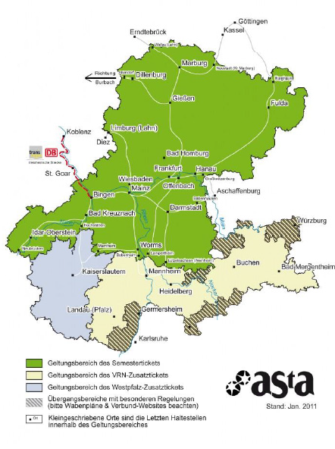

With your student ID, you can also visit the theatre Staatstheater Mainz for free! For more information see page 31.

36



TUTORIAL SECTION



##### HOW TO ACTIVATE YOUR STUDENT ACCOUNT

Once you are enrolled, you will receive your log-in data for your student account. Your username and password enable you to log into any computer on campus, to use your own student email account as well as the printers and photocopiers all across campus and to log in to JOGU-StINe. You will also have access to the WIFI on the campus and in the dormitories. With your account you can also log in to the JGU apps and use the semester ticket and library card.

##### ACTIVATING YOUR ACCOUNT

In order to be able to use your student account, you have to activate it:

You will receive an email to your private email address with an individual link and a personal activation code.

After clicking on the link, you have to enter the activation code. Then you can create your personal password.

|  |
| --- |
| Shape  Description automatically generated with low confidencePlease access your **student email** (...@students.uni- mainz.de) regularly, since some offices only use this address to contact you!  You can also set up a **forwarding address**. Find out how that works by clicking on: [www.zdv.uni-mainz.de/mailweiterleitung/](https://www.zdv.uni-mainz.de/mailweiterleitung/) (link in German) |

##### CREATING A SAFE PASSWORD

##### Please note the following rules for your password:

##### [www.en-zdv.uni-mainz.de/account-change-of-password/](https://www.en-zdv.uni-mainz.de/account-change-of-password/)

Your password should consist of…

* at least 12 characters
* from the following categories:
* upper case letters (A…Z)
* lower case letters (a…z)
* numbers (0…9)
* symbols (!”$%&/()=?)

Please avoid:

* characters which are not part of all keyboards, such as: §, Ä,ö, ü, Ö, Ü
* words from dictionaries
* parts of your first or last name
* your old password
* y, Y, z or Z

##### CHANGING YOUR PASSWORD

##### Please write down your password or take a photo of it. In case you happen to forget it anyway, you can change it here: [account.uni-mainz.de/password](https://account.uni-mainz.de/password)

37



TUTORIAL SECTION

##### CERTIFICATES OF ENROLLMENT AND EXMATRICULATION

If you need a certificate of **enrollment** at JGU in order to submit it to authorities or your home university, for example, you can print it out yourself.

You can also print out your certificate of **exmatriculation,** for your time at JGU, yourself. You will need a certificate of exmatriculation in case you plan to spend another semester abroad or complete a degree in Germany. The certificate is made available mid-April (winter semester) or mid-October (summer semester).

In order to access the certificates, log into JOGU-StINe and select “Service” – “My Documents”. Download your documents from the online portal and save them in order to have permanent access to them.

|  |
| --- |
| The Access to the online platform JOGU-StINe is limited to the duration of your enrollment and will be deleted the semester after the end of your stay  Your documents are provided only in electronic form and will **not** be sent via email. |

38

UPDATE YOUR ADDRESS

Please use your student account to log into JOGU-StINe and update your address once you moved into Mainz.

In order to do so, click on "Service" > "Personal Details" > "Change" > "Save".

If you move later, please always remember to change your address here.

##### UPLOAD A PICTURE

You can upload two pictures in your account:

1. Account picture  
   = profile picture for Skype, Outlook, MS Teams, etc.
2. ****ID Photo  
   = for use of your semester ticket and your student ID.  
   **You CANNOT access your semester ticket in the app without an ID photo.**

For further information (link in German):

##### [www.zdv.uni-mainz.de/account-benutzerbilder-hochladen-aendern/](http://www.zdv.uni-mainz.de/account-benutzerbilder-hochladen-aendern/)



TUTORIAL SECTION

##### JGU APP and JGU AUSWEISE (=ID cards) APP

As a JGU student, you have 2 important apps at your disposal.  In addition to the "JGU App" (= information about studying), there is a separate app "JGU AUSWEISE" for using the semester ticket and the library card.

Please download **both** apps ("JGU APP" and "JGU AUSWEISE") from the Google Play Store or the Apple App Store.

All download information can be found at [www.en-zdv.uni-mainz.de/jgu-app/](https://www.en-zdv.uni-mainz.de/jgu-app/) and [www.en-zdv.uni-mainz.de/jgu-id-card-app/](https://www.en-zdv.uni-mainz.de/jgu-id-card-app/)

How do I register?

You can register using your JGU account. Please upload a **passport photo** for the use of the student ID and the student ticket in the account administration of the JGU [account.uni-mainz.de](https://account.uni-mainz.de/) (see p. 38).

What functions do the apps offer me?

1. JGU AUSWEISE APP

**Digital student ID, digital semester**

If you have any questions about the apps or the passport picture in the account management, please contact the ZDV hotline: [www.en-zdv.uni-mainz.de/hotline/](http://www.en-zdv.uni-mainz.de/hotline/) You can find more information about the App-Ticket at [www.studying.uni-mainz.de/app-ticket/](https://www.studying.uni-mainz.de/app-ticket/).

In exceptional cases, you can have your semester ticket issued in paper form.

**ticket and digital library card**

2. JGU APP

**CampusMap**: Overview of all JGU buildings and libraries

**Display of the semester timetable for students**

**Search function**: Search for contact details, office addresses as well as buildings and departments.

**Public transport**: Timetables for stops on campus.

**Mensa**: The menu plans of refectories and cafeterias on campus (Studierendenwerk and KHG).

**Libraries**: Link to research and UB opening hours.

**ZDV service status**: Current status of the individual ZDV services at JGU.

39



TUTORIAL SECTION

##### REGISTRATION AT THE "BÜRGERSERVICE" MAINZ

During your time in Germany, you have to be registered at the city’s registration office (“Bürgerservice”). You have to make an appointment with the "Bürgerservice" yourself. You can find out how to do this on the next page.

If you live in another city, you have to visit the registration office there in order to register. At the end of your stay, you need to de-register again.

** You must register yourself within 14 days after your arrival. If there is no appointment available within two weeks of your arrival, simply choose the next possible appointment that is free.**

The checklist will help you to make an appointment at the registration office. You will need the following information to register in Mainz:

|  |
| --- |
| Nachname Last name |
| Geburtsname Birth name |
| Vorname First name |
| Geburtsort Place of birth |
| Staatsangehörigkeit  Nationality |
| Familienstand (ledig/ verheiratet) Civil status (unmarried/ married) |
| Religionszugehörigkeit Religion |
| Bisherige Wohnung im Ausland (Stadt, Land)  Previous location abroad (City Country) |

FOR THE REGISTRATION, YOU NEED TO BRING:

* "**Wohnungsgeberbestätigung**": You receive this from the Studierendenwerk (if you sign the rental contract there) or from your private landlord
* **Passport/identity card**

|  |
| --- |
| **ADRESS** |
| **Bürgeramt:**  **Abteilung Bürgerservice,**  Stadthaus, Lauteren-Flügel,  Entrance Kaiserstraße 3-5 55116 Mainz  One minute walk from the  Bus & tram stop:  Mainz central station |

40





TUTORIAL SECTION

HOW TO MAKE AN APPOINTMENT ONLINE AT THE „BÜRGERSRERVICE “

You can arrange your appointment under: [otv.mainz.de/](https://otv.mainz.de/)



TERMIN

STEP 1: Click “Bürgerservice/ Ortsverwaltungen”.

STEP 2: Choose “Anmeldung (Zuzug aus

dem Ausland)“.

STEP 3: Optional download of the template „Wohnungsgeberbescheinigung“.   
You receive this from the Studierendenwerk. You only need to download it and have your landlord fills

it out if you live in a private flat.

STEP 4: Choose a day and a time slot.

S. TEP 5: Fill in your personal data

STEP 6: You will receive an email. Confirm the appointment by clicking the link in the email.

STEP 7: Your request will be checked and

you will get a second email with

the final confirmation and information.

VISA

For any and all questions concerning your visa, you can contact us::

[gis@international.uni-mainz.de](mailto:gis@international.uni-mainz.de)

Students who need a visa must make an appointment with the Foreigners’ Registration Office in Mainz AFTER they have registered with the city of Mainz.You can make an appointment online under [otv.mainz.de/](https://otv.mainz.de/) (See instructions on the left)   
Please choose „Abteilung Ausländerangelegenheiten“and then „Aufenthaltserlaubnis zum Studium/Sprachkurs“.   
At the moment there are extremely long waiting times. Therefore, we recommend all students to apply for a visa already in their home country, even if entry without a visa would be possible. **Please read again our advice from Practical Guide 1 (Step 4 - Visa).**

OPENING A BANK ACCOUNT (OPTIONAL)

### You are not required to open a bank account. However, it could be useful if you hail from a non-EU country, for example.

### In order to open an account, you need a tax identification number. This will automatically be sent to you once you registered with the city. If you don’t receive anything, you can go to your local tax office and inquire there. If you have further questions, write us an email using gis@international.uni-mainz.de.

41



TUTORIAL SECTION

18,36 € each month

##### HOW TO REGISTER FOR THE LICENCE FEE

Once you registered at the

„Bürgerservice Mainz“, you are also required to register for the so called

**P****LEASE** **NOTE**:

After submitting your online registration, you will receive a confirmation. As soon as the payment is due, you will receive a notification from the “Rundfunkbeitragservice” via regular mail/post. With this notification, you will receive information about the payment and the recipient account (IBAN and amount).

***BUT I DON'T HAVE A TV!***

The payment is due regardless of whether you possess a TV or a radio since all programs are also available online.

**SHARED APARTMENT = SHARED FEE**

If you live in a shared apartment, please check with your flat mates to see if somebody is already paying because each household only has to pay once (not per person but per apartment door). If this is the case, you can deregister at: [www.rundfunkbeitrag.de/buergerinnen_und_buerger/formulare/abmelden/index_ger.html](https://www.rundfunkbeitrag.de/buergerinnen_und_buerger/formulare/abmelden/index_ger.html)

(German version only)

**ALL OF THE INFORMATION FOR STUDENTS IS SUMMARIZED AT:**

[www.rundfunkbeitrag.de/welcome/englisch/index_ger.html](http://www.rundfunkbeitrag.de/welcome/englisch/index_ger.html)

„Rundfunkbeitrag (licence fee)“ which finances the public sector media.

You can register under

[www.rundfunkbeitrag.de/buergerinnen_und_buerger/formulare/index_ger.html](http://www.rundfunkbeitrag.de/buergerinnen_und_buerger/formulare/index_ger.html)

STEP 1: Choose “Wohnung anmelden" and “Online ausfüllen”

STEP 2: Fill in your personal data

STEP 3: Insert data of the room/flat

STEP 4: Choose your payment pattern and method

 STEP 5: Re- check your information for accuracy, if necessary, click on "Korrigieren" to correct, something. If everything is fine, click

42

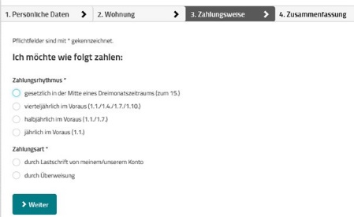

1. PAYMENT PATTERN

Decide between 1 in the middle of a

three-month period (by

the 15th)

1. quarter- yearly (3 months) in advance
2. half-yearly (6 months)

in advance

1. annually in advan- ce (only if you stay 2

2 PAYMENT METHOD

Decide between

1 “Lastschrift” – automatic transfer 2 own bank transfer

semesters)



TUTORIAL SECTION

##### HOW TO RECEIVE AND USE THE STUDICARD

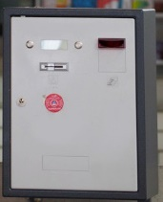

money

card

The StudiCard enables you to pay without cash in the Mensa and cafeterias as well as use printers and photocopiers on campus and wash machines and dryers in the dormitories.

HOW TO OBTAIN THE STUDICARD

You can get the StudiCard for 5 Euro at the:

**Info-Point,** (Studihaus, Staudinger weg 21, Entrance F), or in **mensa and all cafeterias** on campus:

* Mensaria
* INSGRÜNE Cafébar im Philo
* Mensa Georg Forster
* 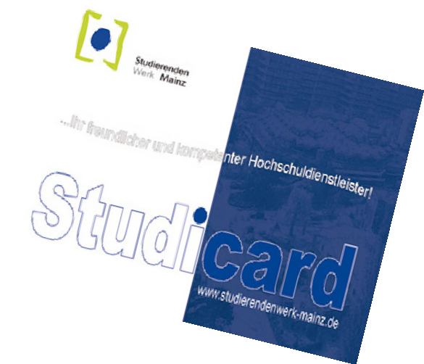Café Rewi

The only reason you **DON’T NEED** to buy the StudiCard is if you received it as a **key** for your dormitory apartment (except Hechtsheim and Weisenau).

In order to pick it up you need to bring:

* + Your student ID (App)
  + A valid photo ID (passport)
  + 5 Euro for issuing the card

HOW TO LOAD MONEY

Your Studicard has the function to automatically reload as soon as it runs out of money (**Autoload**).

To activate this function, you must first share your bank information with the staff of the Info-Point.



Alternatively you can also use the so called „**Kartenaufwerter**“, to load money on the card. You find them in the Mensa or in any cafeteria. The

machine only accepts bills (no coins!)

|  |
| --- |
| PLEASE NOTE:  There are two different acounts on your StudiCard.   1. GENERAL ACCOUNT   this is the money you load on your card via the “Kartenaufwerter” (see picture above) and which you use to pay in the Mensa.   1. PRINTING ACCOUNT   this allows you to use the campus printing system. In order to load money on your printing account, you first have to make sure that you have enough money on your “general account”, then to go to a service terminal e.g. in the University Library (UB) and choose “Geld aufbuchen” (more details on page 44). **Bonus of ZDV:** You get 2.50 euros for free on your printing account! |



43



TUTORIAL SECTION

HOW TO PRINT

You can print and scan in most of the libraries or in the ZDV (Data center) computer pool. For this you need your StudiCard (see previous page).

You can also check out these detailed instructions

[www.en-zdv.uni-mainz.de/operating-instructions-for-service-terminals/](https://www.en-zdv.uni-mainz.de/operating-instructions-for-service-terminals/)

CHARGE PRINT ACCOUNT

STEP 1: FIND A SERVICE TERMINAL (COMPUTER)

Go to a service terminal, e.g. in the University Library (UB)

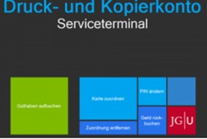More locations: [www.en-zdv.uni-mainz.de/service-terminal-locations/](https://www.zdv.uni-mainz.de/standorte-serviceterminals/) The service terminal's screen will look like this:

STEP 2: ASSIGNING YOUR STUDI- CARD

* Click on “Karte zuordnen”
* Log in with your student account (you received the login data during the matriculation).
* Change your PIN (only numbers, at least 4)

44

STEP 3: LOAD MONEY ON YOUR STUDICARD PRINTING ACCOUNT

First you have to check if you have enough money on your card's general account. If you do, follow the next steps:

* Click “Druckguthaben aufbuchen” on the service terminal screen
* Hold your card to the black/blue – scanner
* Enter your PIN
* Hold your card to the other scanner (light blue/grey)
* Follow step 1-4:

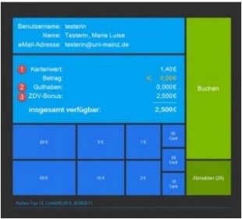

3 The new amount will be shown here (in yellow)

2 Confirm

1 Choose an amount

4 Sign out & take your card with you ☺

PRINTING

* Send your print jobs to the printer

\\jgu-ps-1.zdv.net\Drucken or

upload them online under [drucken.zdv.net/app](https://drucken.zdv.net/app)

* Put your Studicard on the card- reader

at the side of the printer

* Enter your PIN, choose your print job

##### FINDING LITERATURE IN LIBRARIES AND ONLINE CATALOGUE



TUTORIAL SECTION

You will find a wide variety of lib- raries on campus.

Except for libraries from the Medi- cine and Psychology departments, all other departments are repre- sented on the campus.

You can find an overview of all libraries and their addresses here:

[www.ub.uni-mainz.de/en/standorte](http://www.ub.uni-mainz.de/en/)

See also the campus map at the end of the guide for the exact locations.

In the online catalogue (“Recher- cheportal”) you can check out where to find certain books and browse through the huge digital catalogue of literature: [hds.hebis.de/ubmz/index.php](https://hds.hebis.de/ubmz/index.php)

In most of the libraries, you can also find computer rooms where you have the opportunity to scan and print out literature.

HOW TO OBTAIN A LIBRARY CARD

If you want to borrow books, you will need a library ID. You can apply for this online and use it with the JGU app.

You can find detailed instructions here:

[www.ub.uni-mainz.de/de/bibliotheksausweis-beantragen](https://www.ub.uni-mainz.de/de/bibliotheksausweis-beantragen)



|  |
| --- |
| BORROWING AND RETURNING BOOKS  **Please** **note**: In most libraries, taking books home for long periods of time is not permitted. Most likely you may only borrow them overnight or for a weekend. Exeption: University Library - There, you can borrow books for up to 4 weeks. In order to borrow books there, use the book scanners at the entrance of the “Lehrbuch-sammlung”. You put your library card in the slot and enter your library card PIN (your date of birth in the format dd/mm/yy) or use the JGU-app. |

 

45



TUTORIAL SECTION

##### IN CASE OF EMERGENCY...

The most important number for you is 112. You only need to dial this number (free of charge) in order to reach the emergency services – police, medical ser- vices or fire brigade – anywhere in Germany and Europe immediately.

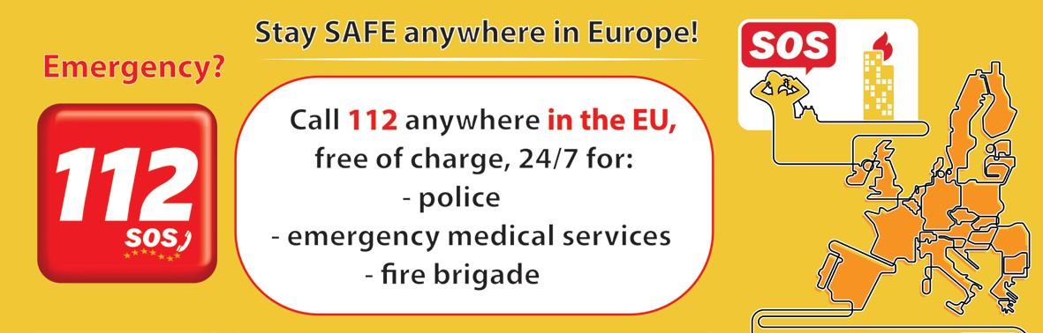

More important local emergency addresses and numbers in and around Mainz:

|  |  |
| --- | --- |
| Suspicion of a **Corona** infection: central patient service | 116117 |
| Gesundheitsamt Mainz/ Landkreis Mainz-Bingen | **Corona-Hotline: 06131 - 69333-4275**  [www.mainz-bingen.de/de/Aemter-Abteilungen/Gesundheit/](http://www.mainz-bingen.de/de/Aemter-Abteilungen/Gesundheit/)corona@mainz-bingen.de |
| Emergency medical services/ ambulance | Tel.: 19 222 |
| Police | Tel.: 110 |
| Central Phone number University Hospital Mainz | 06131-17-0 |
| Poison helpline | 06131 - 19240 or 0700/44384636 |
| Hospitals Mainz and Rhineland Palatinate | https://www.mainz.de/leben-und-arbeit/soziale-hilfen-pflege-gesundheit/gesundheit/krankenhaeuser.php |
| Pharmacy (German: Apotheke) emergency service | https://www.aponet.de/apotheke/notdienstsuche/55116/%20/5  Tel.: 0180-5-258825-PLZ  (In place of the “PLZ” add your postal code to the number given above)  [www.lak-rlp.de](http://www.lak-rlp.de) |
| Medical emergency service Mainz Marienhaus Hospital Mainz | An der Goldgrube 11, 55131 Mainz Tel.: 116 117  Weekend: Fri 4pm - Mon 7am  Weekdays: 7pm - 7am / Wed 2pm – Thu 7pm |

We hope that you will not need one of these emergency services while you are in Mainz, but it is always good to know where to get quick help in case of an emergency.   
Of course, you can always contact us in case of emergency or afterwards, no matter what has happened (accident, violence, theft….) – we are there to support and assist you!

GIS Services: +49 16131 39-20695 or [gis@international.uni-mainz.de](mailto:gis@international.uni-mainz.de)

46

47

1. PUBLISHING DETAILS

PUBLISHER

International Office of the Johannes Gutenberg University Mainz Gutenberg International School Services (GIS Services)

EDITORIAL TEAM

Fouad Ahsayni Lea Friedmann Lara Neef Naomi Eckhardt

Silke Jennerich Heidi Rotroff Dr. Thomas Weik Carolin Schrenk Annika Flügel Jan Koloska Manal Al-Towaie

LAYOUT AND DESIGN

Lea Friedmann

EDITION

August 2022

CONTACT

Johannes Gutenberg University Mainz International Office

Gutenberg International School Services (GIS Services)

[gis@international.uni-mainz.de](mailto:gis@international.uni-mainz.de) [www.international-office.uni-mainz.de/](http://www.international-office.uni-mainz.de/) exchange/

ICONS & FOTOS

YouTube icon, Icon made by Pixel perfect from www.flaticon.com, S. 1, Traveler with a suitcase free icon, Icon made by Freepik, [www.](http://www/) freepik.com, from [www.flaticon.com,](http://www.flaticon.com/) S. front, 7,10,11, Black plane free icon, Icon made by Google, google.com, from www.flaticon.com S. 10, Bus and Train Silhouettes free icon, Icon made by Scott de Jonge, [http://www.scottdejonge.com,](http://www.scottdejonge.com/) from [www.flaticon.com,](http://www.flaticon.com/) S. 10, 34, Bicycle free icon, Icon made by Freepik, [www.freepik.com,](http://www.freepik.com/) from [www.flaticon.com,](http://www.flaticon.com/) S. 11, Creative free icon, Icon designed by Good Ware, from Freepik, [www.freepik.com,](http://www.freepik.com/) [www.flaticon.com,](http://www.flaticon.com/) S. 11, 14, 16, 24, 35, 41, Calendar free icon, Icon made by Smashicons, smashicons.com, from [www.flaticon.com,](http://www.flaticon.com/) front, S. 8, 9, Home free icon, Icon made by Smashicons, [www.](http://www/) smashicons.com, from [www.flaticon.com,](http://www.flaticon.com/) front, S. 12,15 Placeholder free icon, Icon made by Freepik, [www.freepik.com,](http://www.freepik.com/) from [www.](http://www/) flaticon.com S. 21, 29, 31 Pin free Icon, Icon made by Smashicons, smashicons.com, from [www.flaticon.com,](http://www.flaticon.com/) S. 13, Hand gesture raising the index finger free icon, Icon made by Freepik, [www.freepik.com,](http://www.freepik.com/) from [www.flaticon.com,](http://www.flaticon.com/) S. 17, 21, 22, 23, 24, 36, 37, 38, 40, 43, 38, 41, Welcome free Icon, Icon made by Freepik, [www.freepik.com,](http://www.freepik.com/) from [www.flaticon.com,](http://www.flaticon.com/) S. 14- 25, Funds free icon, Icon made by Freepik, [www.freepik.com,](http://www.freepik.com/) from [www.flaticon.com,](http://www.flaticon.com/) S. 25, Medical insurance free icon, Icon made by Freepik, Freepik, [www.freepik.com,](http://www.freepik.com/) from [www.flaticon.com,](http://www.flaticon.com/) S. 25, Wifi connection signal symbol free icon, Icon made by Rami McMin, RamiMcM.in, from [www.flaticon.com,](http://www.flaticon.com/) S. 35, Magnifying glass free icon, Icon made by Freepik from [www.flaticon.com,](http://www.flaticon.com/) S. 22, 25, October free icon, Icon made by Freepik from [www.flaticon.com,](http://www.flaticon.com/) S. 21, 25, Exam free icon, Icon made by Freepik from [www.](http://www/) flaticon.com, S. 24, Open book free icon, Icon made by Zlatko Najdenovski, [www.flaticon.com/author](http://www.flaticon.com/authors/zlatko-najdenovski)s/zlatk[o-najdenovski,](http://www.flaticon.com/authors/zlatko-najdenovski) from [www.flaticon.com,](http://www.flaticon.com/) S. front, 20, 43, Campus free icon, Icon made by Freepik, [www.freepik.com,](http://www.freepik.com/) from [www.flaticon.com,](http://www.flaticon.com/) S. front, S. 25-33, Pot free icon, Icon made by Freepik from [www.flaticon.com.](http://www.flaticon.com/) S. 26, 27, Coffee cup free icon, Icon made by Freepik, [www.](http://www/) freepik.com, from [www.flaticon.com,](http://www.flaticon.com/) S. 26, 27, Pepper Mill free icon, Icon made by Freepik, [www.freepik.com,](http://www.freepik.com/) from www.flaticon. com, S. 27, Fork free icon, Icon made by Freepik, [www.freepik.com,](http://www.freepik.com/) from [www.flaticon.com,](http://www.flaticon.com/) S. 25, 26, Joy free icon, Icon made by Retinaicons, [www.flaticon.com/author](http://www.flaticon.com/authors/retinaicons)s/r[etinaicons,](http://www.flaticon.com/authors/retinaicons) from [www.flaticon.com](http://www.flaticon.com/) front, S. 25, 28 Contract free icon, Icon made by Freepik, [www.freepik.com,](http://www.freepik.com/) from [www.flaticon.com,](http://www.flaticon.com/) S. 22, 25 Printer free icon, Icon made by Gregor Cresnar, www.flaticon.com/authors/gregor-cresnar, from [www.flaticon.com,](http://www.flaticon.com/) S. 22, 41-43, Man Certificate free icon, Icon made by Freepik, www.freepik. com, from [www.flaticon.com,](http://www.flaticon.com/) S. 23, Graduated student free icon, Icon made by Freepik, [www.freepik.com,](http://www.freepik.com/) from www.flaticon.com, S. 23, Communication free icon, Icon made by Freepik, [www.freepik.com,](http://www.freepik.com/) from [www.flaticon.com,](http://www.flaticon.com/) S. 23, Map free icon, Icon made by Smashicons, [www.smashicons.com,](http://www.smashicons.com/) from [www.flaticon.com,](http://www.flaticon.com/) front, 25,30, Settings free icon, Icon made by Smashicons, [www.](http://www/) smashicons.com, from [www.flaticon.com,](http://www.flaticon.com/) front, S. 34-44, Theater masks couple free icon, Icon made by Freepik from www.flaticon. com, S. 29, 34, Question free icon, Icon made by Freepik, [www.freepik.com,](http://www.freepik.com/) from [www.flaticon.com,](http://www.flaticon.com/) front, 7, 15 Chat free icon, Icon made by dmitri13, [www.flaticon.com/authors/dmitri13,](http://www.flaticon.com/authors/dmitri13) from [www.flaticon.com,](http://www.flaticon.com/) front,15 Computer free icon, Icon made by Freepik from [www.flaticon.com,](http://www.flaticon.com/) S. 20, 33, 43, City hall free icon, Icon made by Creaticca Creative Agency, http://www.creaticca. com/, from [www.flaticon.com,](http://www.flaticon.com/) S. 25, 39, Coins free icon, Icon made by Smashicons, smashicons.com/, from [www.flaticon.com,](http://www.flaticon.com/) S. 40, Sunset free icon, Icon made by monkik, [www.flaticon.com/author](http://www.flaticon.com/authors/monkik)s/monkik[,](http://www.flaticon.com/authors/monkik) from [www.flaticon.com,](http://www.flaticon.com/) S. 34, Video camera free icon, Icon made by Good Ware, [www.flaticon.com/authors/goodwar](http://www.flaticon.com/authors/goodware)e, from [www.flaticon.com,](http://www.flaticon.com/) S. 33, Pencil free icon, Icon made by Situ Herrera, [www.rivolta.es,](http://www.rivolta.es/) from [www.flaticon.com,](http://www.flaticon.com/) S. 20, 22, Passport free icon, Icon made by Freepik, [www.](http://www/) freepik.com, from [www.flaticon.com,](http://www.flaticon.com/) S. 25, 39, Credit card free icon, Icon made by Dave Gandy, [fontawesome.io,](http://fontawesome.io/) from [www.](http://www/) flaticon.com, S. 39, Studicard, [www](http://www).studier[endenwerk-mainz.de/essentrinken/studicard/?L=3,](http://www.studierendenwerk-mainz.de/essentrinken/studicard/?L=3) S. 41, Kartenaufwerter, [www.studierendenwerk-mainz.de/essentrinken/studicard/](http://www.studierendenwerk-mainz.de/essentrinken/studicard/) , S. 41, Suitcase with white details, icon mady by Daniel Bruce, [http://www.](http://www/) danielbruce.se, from [www.flaticon.com,](http://www.flaticon.com/) S. 7, Pillar free icon, Icon made by Freepik, [www.freepik.com,](http://www.freepik.com/) from [www.flaticon.com,](http://www.flaticon.com/) S. 19, Holding hands in a circle free icon, Icon made by Freepik, [www.freepik.com,](http://www.freepik.com/) from [www.flaticon.com,](http://www.flaticon.com/) S. 19, Speech bubble free icon, Icon made by Freepik, [www.freepik.com,](http://www.freepik.com/) from [www.flaticon.com,](http://www.flaticon.com/) S. 19, List free icon, Icon made by Gregor Cresnar, [www.flaticon.com/authors/gregor-cresnar,](http://www.flaticon.com/authors/gregor-cresnar) from [www.flaticon.com,](http://www.flaticon.com/) S. 19, Skyline free icon, Icon made by Freepik from [www.flaticon.com,](http://www.flaticon.com/) S. 25, Schedule free icon, Icon mady by Pause08, [www.flaticon.com/author](http://www.flaticon.com/authors/)s/ pause08, S. 18, College graduation free icon, Icon made by Freepik, [www.freepik.com,](http://www.freepik.com/) from [www.flaticon.com,](http://www.flaticon.com/) S. front, 17, 20, Checklist free icon, Icon made by Freepik, [www.freepik.com,](http://www.freepik.com/) from [www.flaticon.com,](http://www.flaticon.com/) front, S. 6, 7, Mask free icon, Icon from Microsoft 365[,](http://www.flaticon.com/) S. 2, Coronavirus free icon, Icon from Microsoft 365[,](http://www.flaticon.com/) S. 3, [www.rundfunkbeitrag.de/](http://www.rundfunkbeitrag.de/)



48